🕹️ Programming Practical Handout: Thinking Like a Programmer

1. Warm-Up: Precise Instructions
Write step-by-step instructions for drawing a simple picture (e.g., a house, a smiley face, or a stick figure). Another student will follow your instructions literally. Computers don’t guess, so you must be precise!
Your Instructions:
Start in the top left corner. Draw a line straight down. From there draw a line to the right. Then draw a line up. Then draw a line right. You have drawn a square

2. Human Robot Game
On a 5×5 grid, place coins (you can do it via paint or excel if you wish). Write instructions (UP, DOWN, LEFT, RIGHT, PICK UP) for your robot to collect all the coins.
Your Robot Instructions:
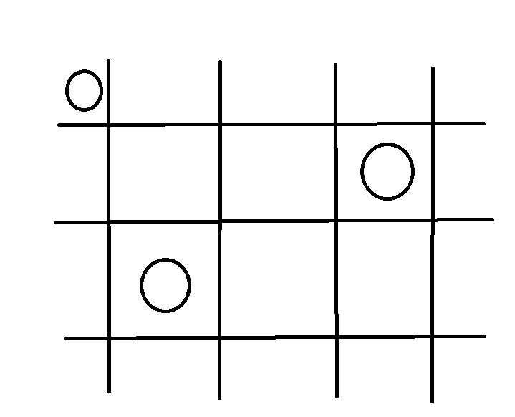
Start in the top left. PICK UP. RIGHT, RIGHT, RIGHT, DOWN, PICK UP. DOWN, LEFT, LEFT, PICK UP.

3. Game Rule Breakdown
Pick a simple game (Noughts and Crosses (Tic Tac Toe), Rock-Paper-Scissors, Guess the Number). Fill in the blanks:
Inputs (what the player does):
Data (what the game tracks):
Rules/Logic (how the game works):
End Condition (how it finishes):
Rock paper scissors:
Choose either rock, paper or scissors

Rock beats scissors. Scissors beat paper. Paper beats rock. Matching pair is a draw. Beating the opponent’s choice results in a win.

4. Pseudocode Challenge
Use IF, ELSE, REPEAT, UNTIL to write pseudocode for this game:
Roll a dice until you get a 6, then print 'You win!'
roll dice
IF = 6
Print “you win”
Else
Repeat until = 6

5. Reflection
What was hardest about these tasks? What mistakes did you notice? Write your thoughts below:
The hardest part was making the instructions simplistic enough whilst still carrying the details needed

